Objectives:

* Introduction to JavaFX

**There are 1 challenge exercises, each worth 100%**

**Project #1 (**Working with Images for JavaFX, create a new class and type in the following code)

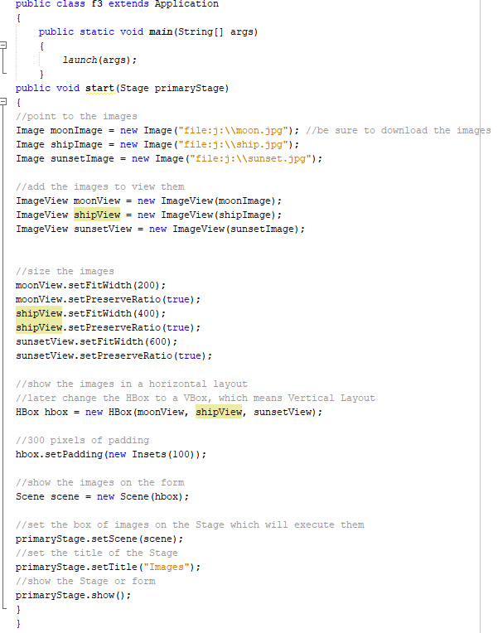

**Project #2** (Create a new class and type in the following code to create a JavaFX GUI application. JavaFX is the new version of GUI).

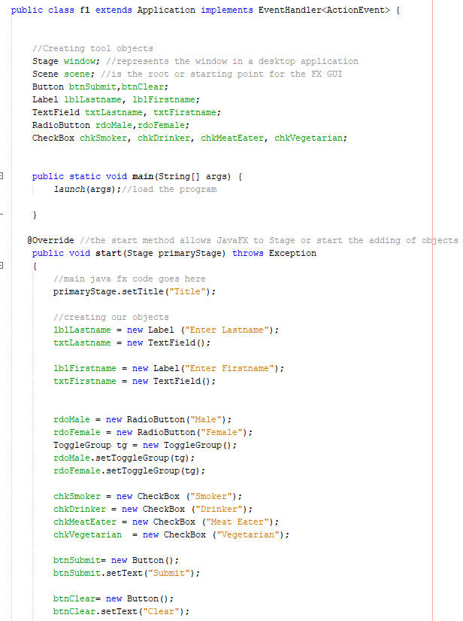

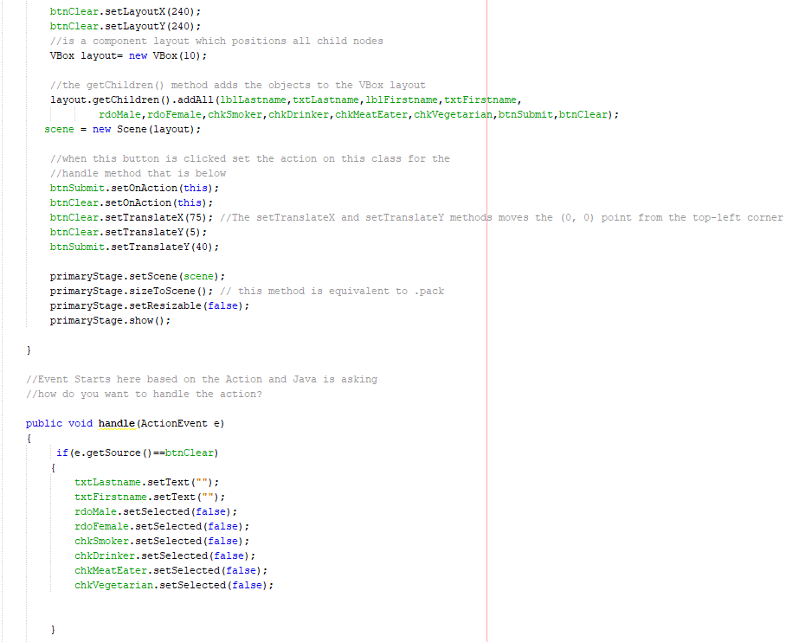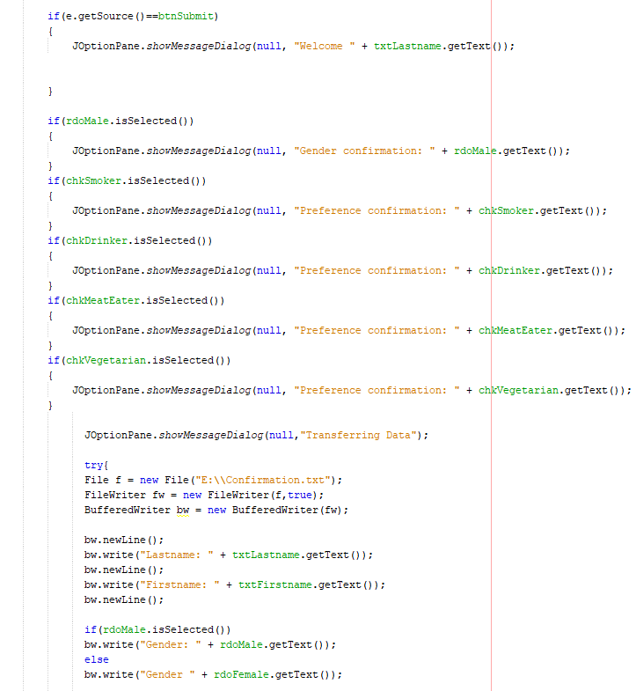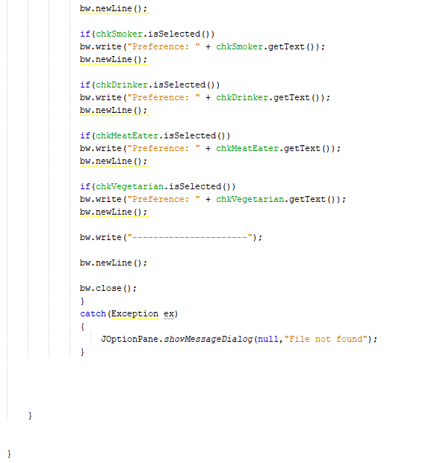

**Project #3** (Working with List controls)

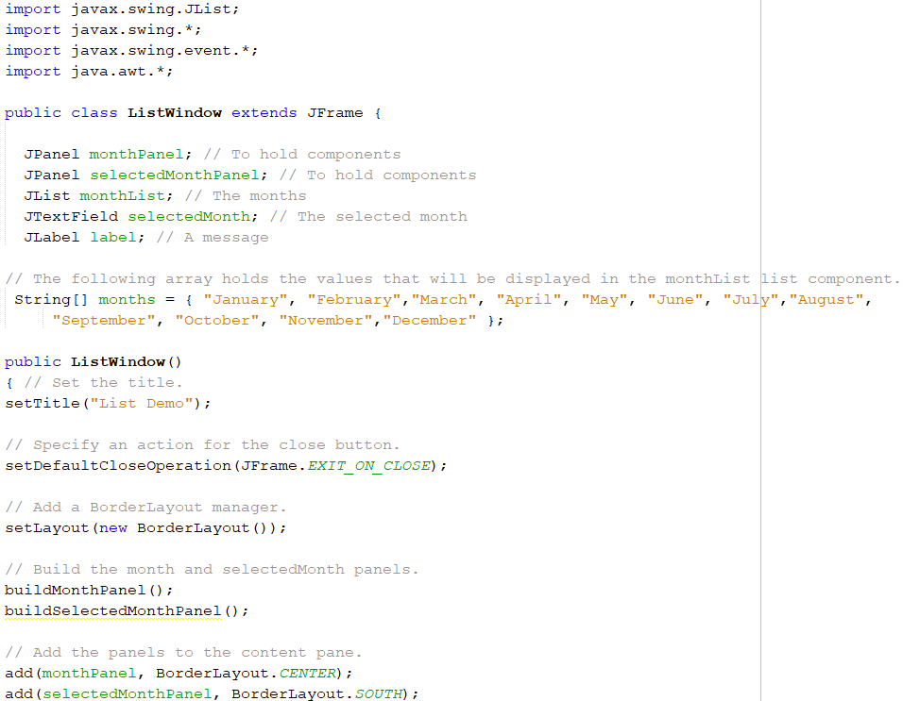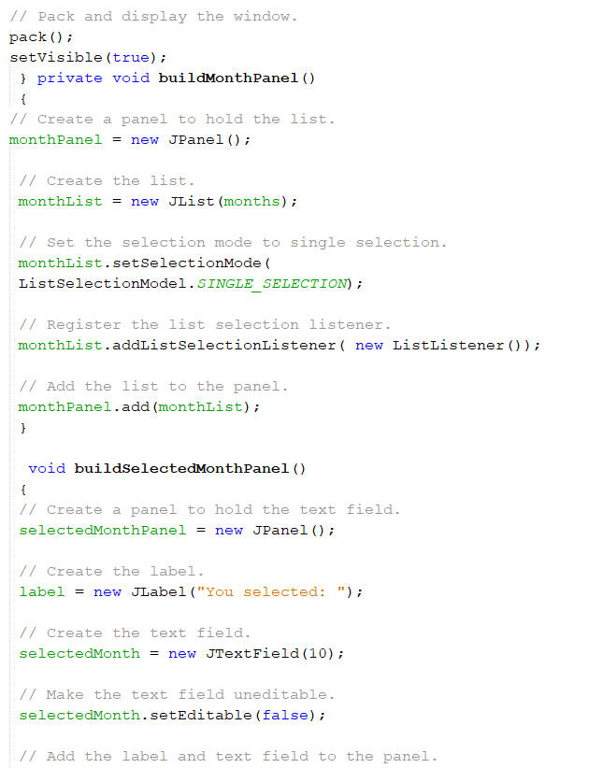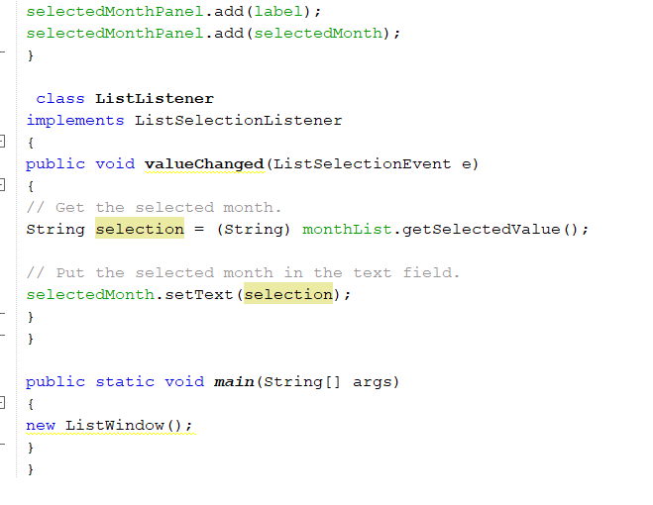

**Challenge Exercise #1:** Create a GUI application for the following below, may use Java FX or JFrame

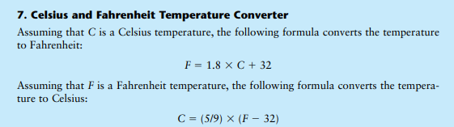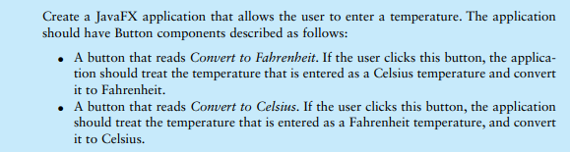

**#1 print screen the running app with output and code below here**

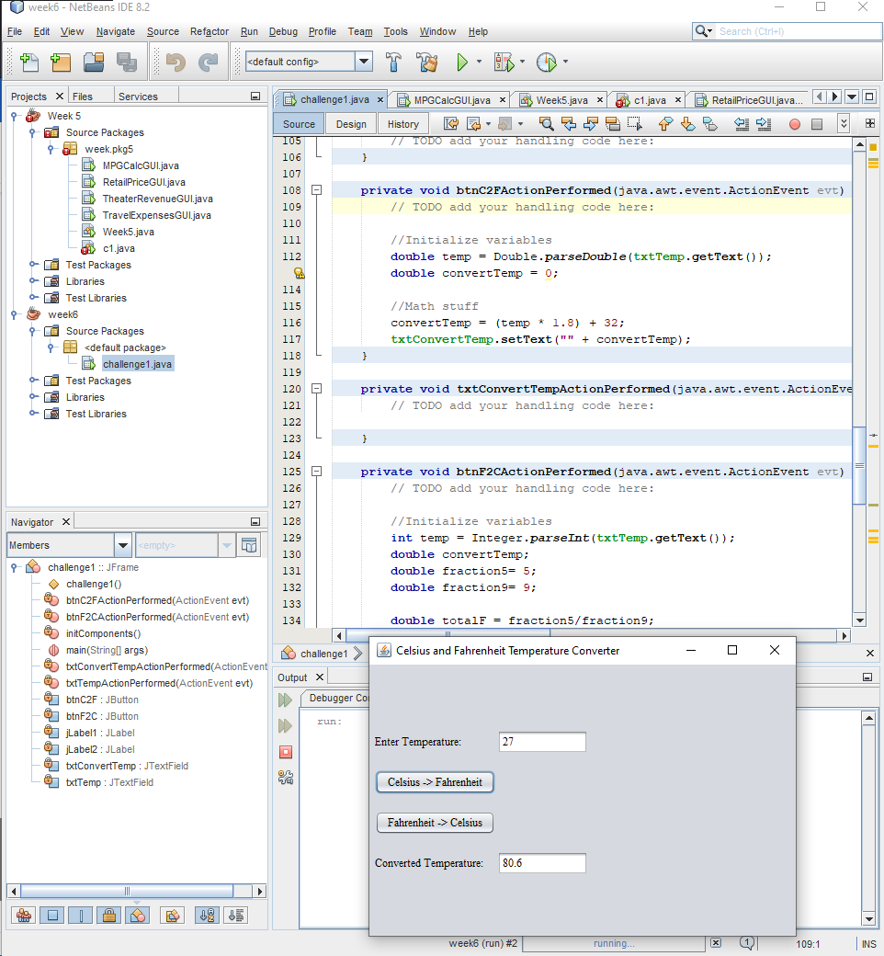

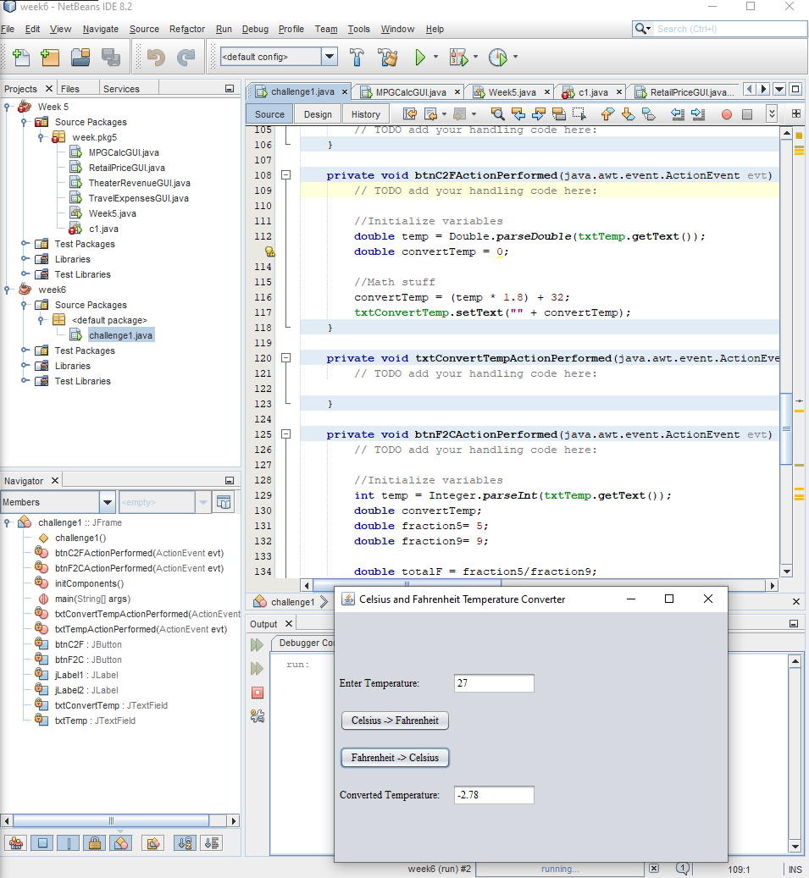

**Submit this document to Module 6 Class Exercise #5**